|  |  |
| --- | --- |
| Pace Maker Team Name Yoldaş Ulaş Talaş | **Target Audience:Ages between 15-25**  **Gamer Type**: Casual and Core  **Target Platforms: Steam**  **Genre:** Rythm  **Number of Players:** 1  **Projected Release Date:29.12.2022** |

# Concept Image

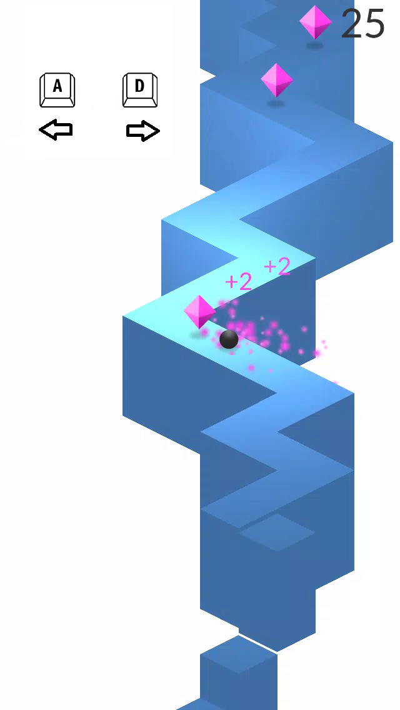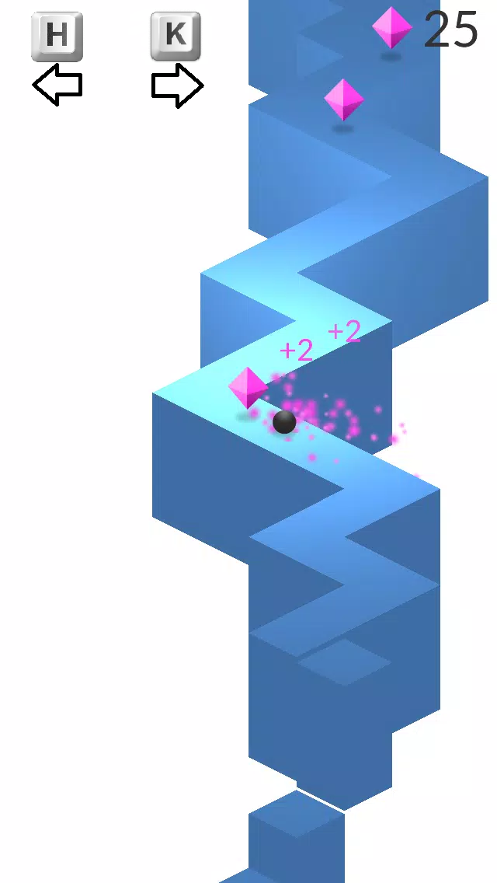

# Elevator Pitch (High Concept Statement)

This game will be a mixture of ZigZag and Crpyt Of The Necrodancer with a bonus feature. I’m planning to combine ZigZags left and right based control and the rythm based play of COTN. As a featıre I will change the input buttons for going left and right with a rhythm music in game.My target audience is rhythm game players and also core gamers that which can play this in a 30 minute interval. The player will use buttons such as A-D H-K Y-I V-N R-Y Z-C Q-E for moving left to right. According to rhythm input buttons will change to A-D to H-K for example. The game will get faster and faster after some point.And if they push the wrong button they will fall from the platform and the game will over.I’m planning to excite the players with ryhtm and lack of knowledge for the what will be the next input keys and when they will change will provide that I believe.I think Steam will be the best option for releasing this game. Since it is good to sell this one time. I will contstruct this game on Unity because of my knowledge is on Unity mostly.

# Feature Set (Pillars of the Game)

* Randomised Input System
* Going Along With Rhythm
* Rhythm Counter which makes you gain bonus points if you go left and right according to songs rhythm.
* In game pop-ups that breaks the 4th wall and talks to you.

**Design Influences**

* Rhythm from Crypt Of The Necrodancer
* Gameplay from ZigZag Game

My game’s difference is the random input change system.

# Game Flow and/or Game Loop

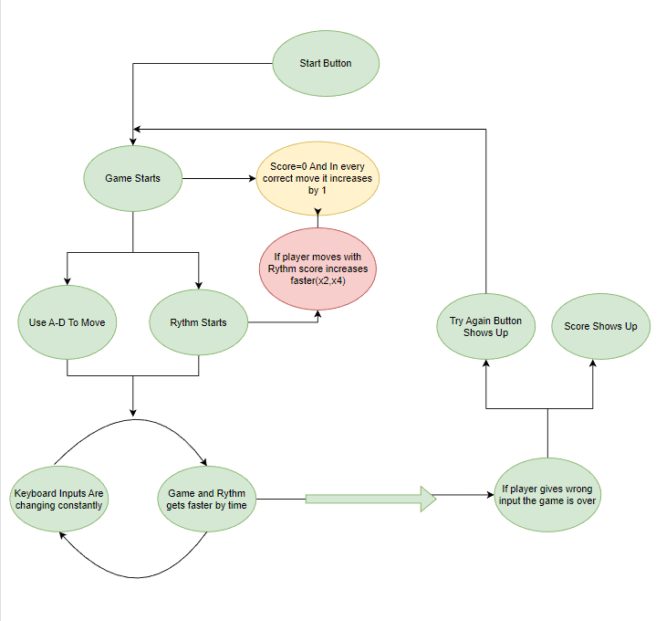

**Scope Management**

* Green Light Features (High Priority)
* Yellow Light Features (Medium Priority)
* Red Light Features (Low Priority)